Fruit

Naam/name ……………………. Vertaal in Engels:

aardbei = strawberry ananas = …………………………
sinaasappel = orange pruim = …………………………….
peer = pear watermeloen = ……………………..

appel = apple perzik = ………………………………
kers = cherry mandarijn = ………………………….
druif = grape mango = ……………………………….
banaan = banana limoen = ………………………………

citroen = lemon kiwi = ………………………………….

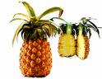 ananas = pineapple citroen = ………………………………

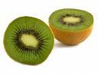kiwi = kiwi banaan = ……………………………….
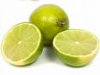 limoen = lime druif = ……………………………….
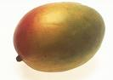 mango = mango kers = ………………………………..
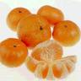 mandarijn = tangerine appel = ………………………………….
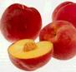 perzik = peach peer = …………………………………..
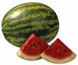 watermeloen = watermelon sinaasappel = ………………………….
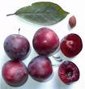 pruim = plum aardbei = …………………………….

Opdracht:

Schrijf de ontbrekende letters erbij: + Nederlandse woord:

. ineappl . = ………………………… …………………………………..

s .rawber.. = ………………………… …………………………………..

pe . ch = ………………………… …………………………………..

tan . eri . e = ………………………… …………………………………..

p .um = ………………………… …………………………………..

. anan . = ………………………… …………………………………..

che. .y = …………………………. …………………………………..

l . me = …………………………. …………………………………..

l. mo . = …………………………. …………………………………..

o. an. e = …………………………. …………………………………..

p. ar = …………………………. …………………………………..

. rap. = …………………………. …………………………………..

. an. o = …………………………. …………………………………..

k. . i = …………………………. …………………………………..

. ate. mel. n = ………………………….. …………………………………..

. p. le = …………………………… …………………………………..

